AKM Sabbir
Interactive Project for Software Engineering CS616
Date: 02/28/2015

Tutorial Application:
This ‘tutorial point’ desktop application has been developed for the students of 6th – 10th grade so that they can learn about structural programming, programming language and IOI submission using languages like C++,python etc. It is developed by using python 2.7 and wxPython. It is platform independent so the program can be run in Linux, Windows, MacOS platform. By using this application students can prepare for competition like the International Olympiad in Informatics. It will help students to learn how to solve easy level programming problems using programming code and also help students to practice critical thinking. To run the application one has to perform the following steps first,
- Download and install python 2.7 from https://www.python.org/download/releases/2.7.5/
- Add installation directory to Environment Variable. If it is windows add the directory to Path variable and if it is Linux then export it to PATH variable.
- Then download and install wxPython from http://www.wxpython.org/download.php
- Open a command prompt go to the directory where application script exist and run the following command:
Python interactive_project.py
Following images is going to show details of it,
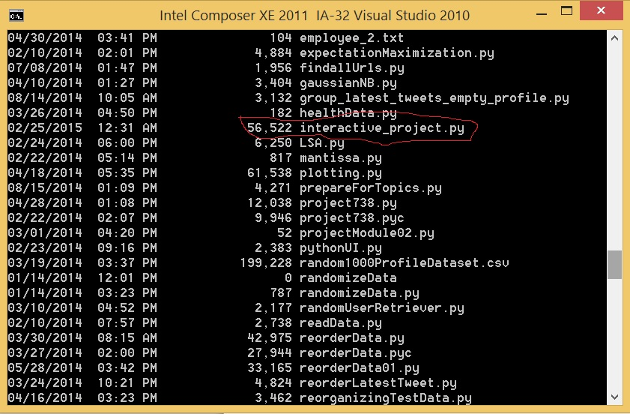
Fig 1:
As I run the dir command in the current directory it shows my project file interactive_project.py along with some other project file. now I am going to run python_interactive project.py
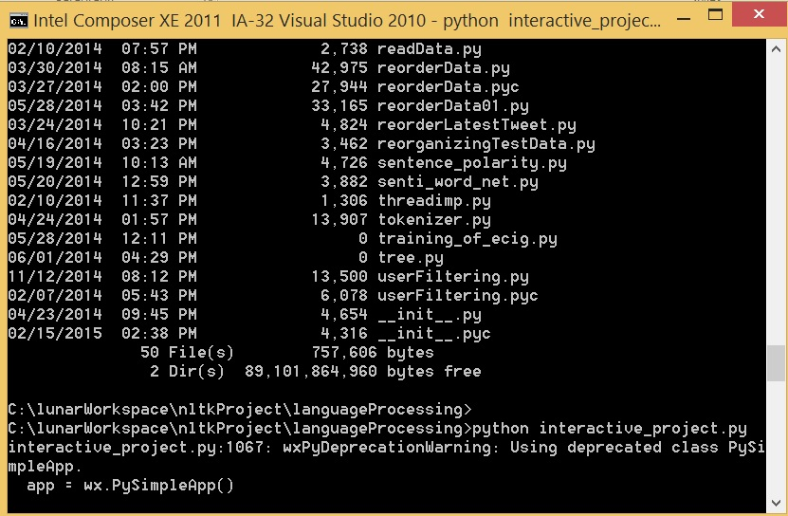
Fig 2:
As soon as user runs the command it starts the wx.PySimpleApp() and generate the following login GUI,
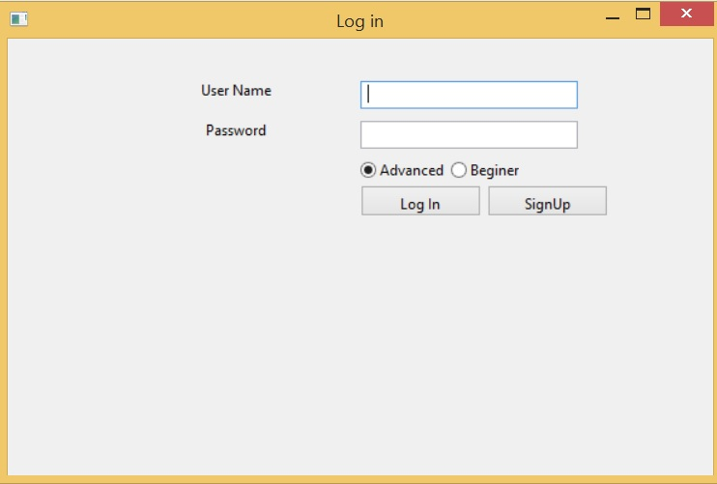
Fig 3:
So any user who want to use the application has to sign up for an account and create the necessary username and password to log into the application. It has two options advanced level for upper grade students and beginner level for mid grad students. Right now I am using the following username and password and advanced level option,

Username: akmsabbir
Password: 0189

After login user will get the following main graphical user interface,

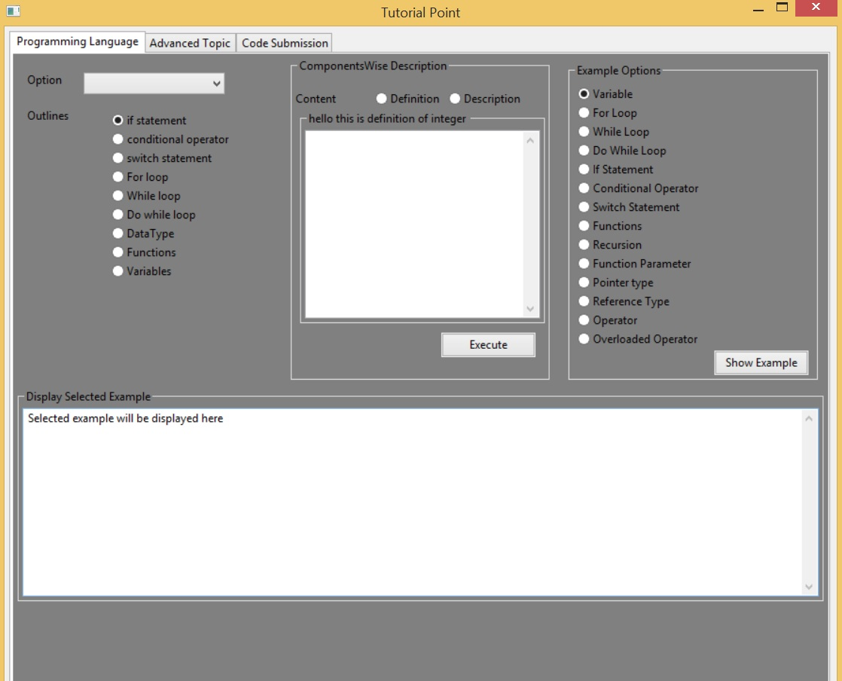
Fig 4:

So the main graphical user interface has three tabs. Each tab covers a specific domain of the problem of learning about programming, programming language, IOI. It might have more tabs covering more topics and area however this is a big project and in a short time I tried to make it concise and demo level presentation. So the different components and options available here are described below:
- Option field helps the user to narrow down his search space for information he is looking for. The available options are ,
    - Loops
    - Variable
    - Datatype
    - Conditional Statement
    - Functions
For instance if user chooses the option Loops he will get the following window,
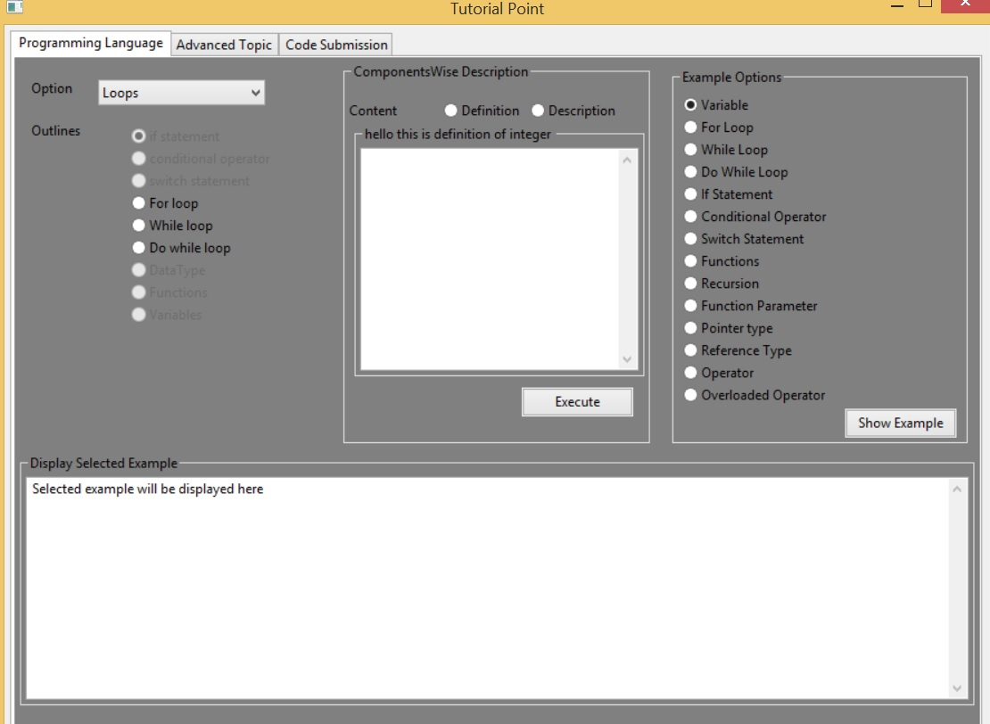Fig 5:
So in the outline area user has three loop options to choose from. Now user can select either content Definition or Description and press the execute button to get more information about it. As the following image shows that,
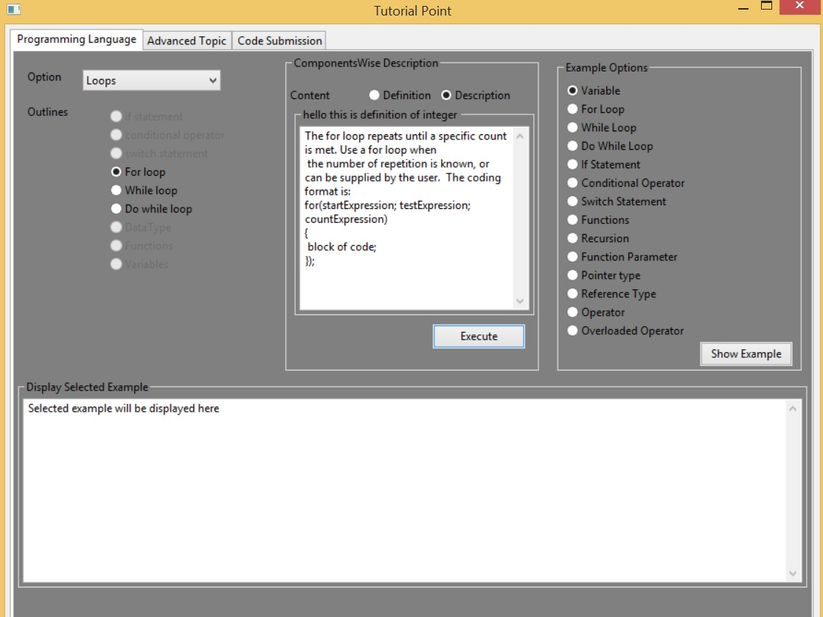
Fig 6:
User can also select an example option to understand the different aspect of programming language domain. Following image shows the presentation of For Loop example,
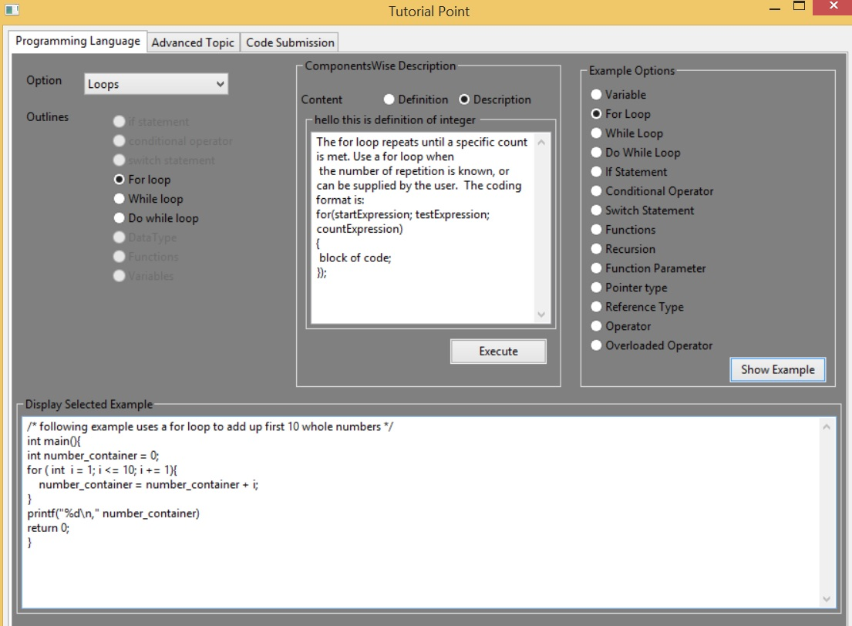
Fig 7:
Introduction with IDE and Writing Solution:
After learning the different aspects of programming language the next step of the tutorial is tech the students about the Integrated Development Environment by using which they are going to write the programming code for different mathematical and IOI problems. There should be an option in this application where user will find details of how to install IDE and how to open a windows console project in it. However I did not developed and attached that option in the application therefore I am going to describe how it can be done using following description.
For visual studio installation just need to do the following steps,
- Download the visual studio from this Microsoft link http://www.visualstudio.com/en-us/products/free-developer-offers-vs.aspx
- Then click on the installation button and perform the custom installation by just clicking the next button
- It may take more than hours to complete the installation process
Now students are ready to open a windows console application using the visual studio. To do that students have to perform the following steps,

- User has to double click the short cut of visual studio to open it. He will get the following window,

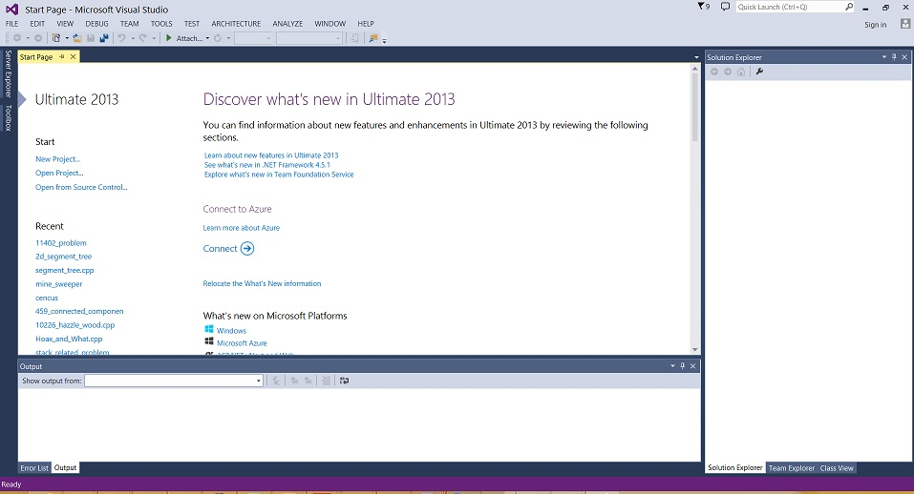
Fig 8:
- Now click the File option at the menu bar and Open New
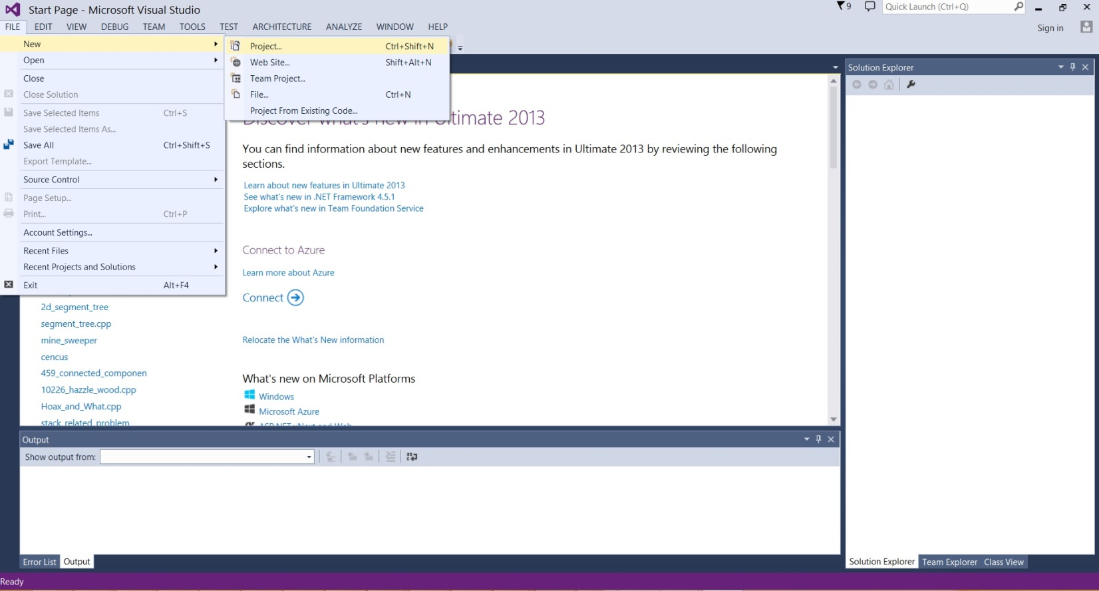
Fig 9:

- When user opens a new project visual studio will give a template where all the installed language will be visible. User has to select his preferable language. For now it is going to be visual C++.
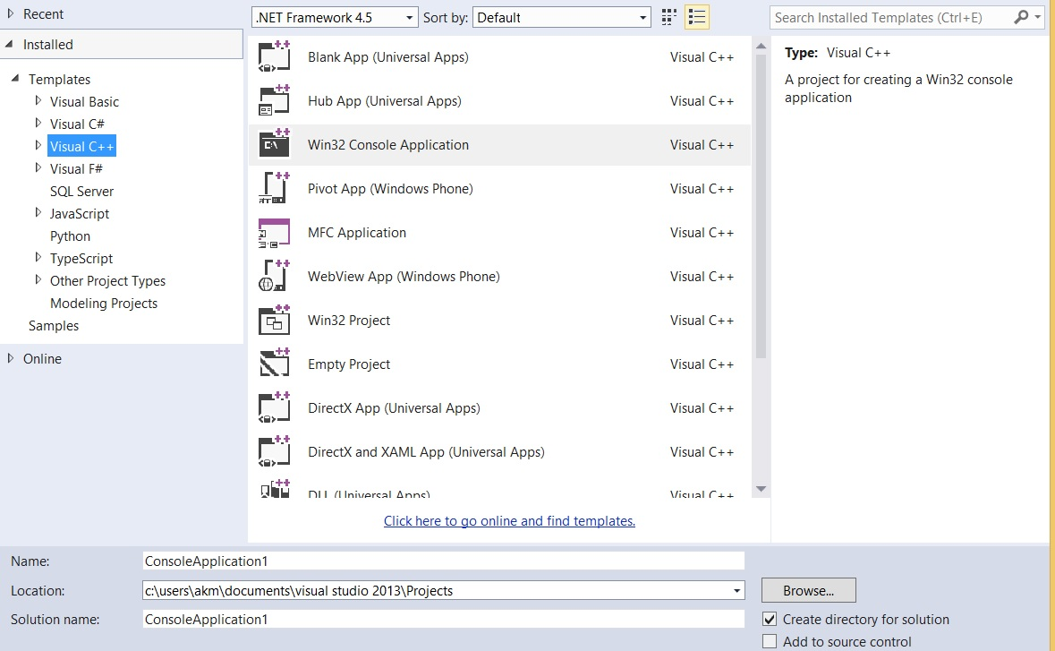
Fig 10:
- After selection of a language; user has to give a valid name of the project and has to select win 32 console application option then press ok button
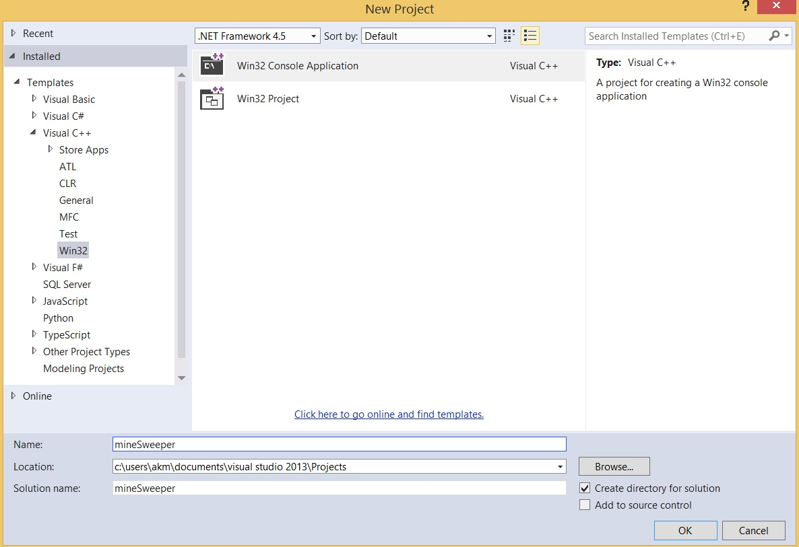
Fig 11:
- When user presses ok it will open the win 32 application wizard. Then user has to press the next button and configure the project as follows. He has to select the empty project option. Deselect the security development life cycle and select the console application option. As it is shown in following image
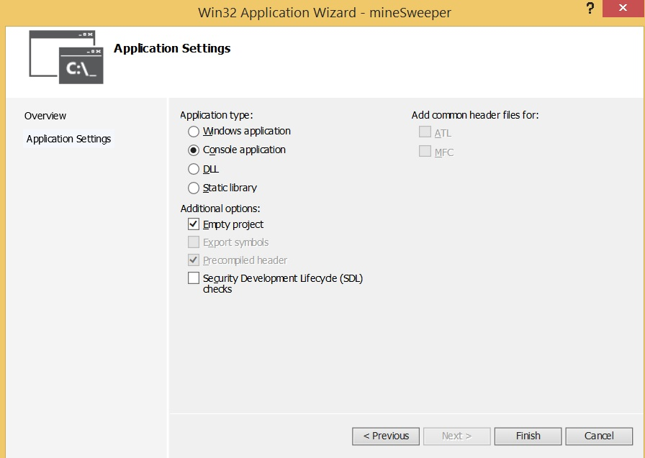
Fig 12:

- Now pressing the finish button will open the project and the solution explorer will look like this
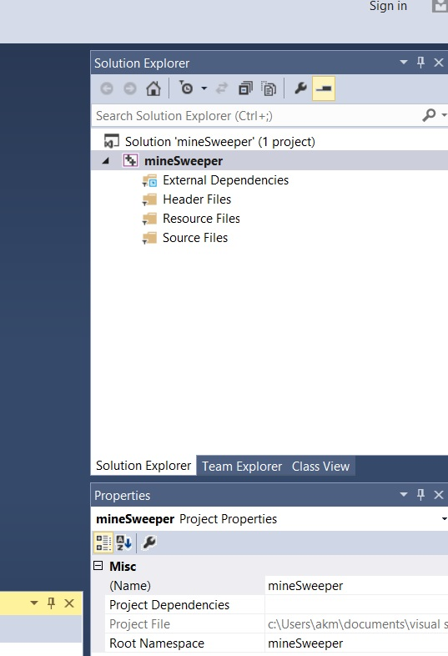
Fig 13:

- Now right click on the Source Files directory and choose add new item to add a new C++ source file and named it main.cpp

I have written a solution for MineSweeper problem. This problem has been taken from ACM UVA site. This site contains thousands of problems can be solved by using programming language. Some of them are IOI level. MineSweeper is one of the easy level problems. Students can expect to face problem like this in International Olympiad in Informatics. The problem description is given below,

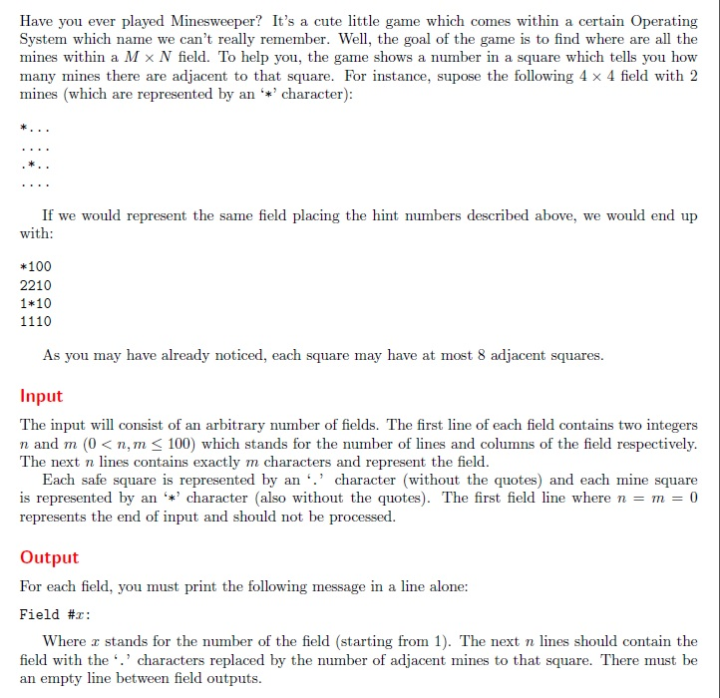
Fig 16:

Solution for above problem written in C++ using visual studio 2013 is,

#include<stdio.h>
#include<iostream>
#include<string>
#include<vector>
using namespace std;
int find_mines(vector<string> source,int x,int y,int sizex,int sizey){
if (x < 0 || y < 0)
return 0;
if (x == sizex || y == sizey)
return 0;
if (source[x][y] == '*')
return 1;
if (source[x][y] == '.')
return 0;
return 0;

}
int main(){

vector<string> str_container;
vector<string> game_board;
vector<int> just_test;
just_test.resize(1000);
printf("%d\n",just_test.capacity());
printf("%d\n",just_test.size());
printf("%d\n",just_test.at(1));
int cases;
string str;
int count = 0;
int sizex,sizey;
while (true){
getline(cin, str);
if (str.empty())
continue;
sscanf(str.c_str(), "%d%d", &sizex,&sizey);
if (sizex == 0 || sizey == 0)
break;
char result[101][101];
for (int i = 0; i < sizex; i++){
getline(cin, str);
str_container.push_back(str);
}

int mine_touched = 0;
for (int i = 0; i < sizex; i++){

for (int j = 0; j < sizey; j++){
int count = 0;
if (str_container[i][j] == '.'){
count += find_mines(str_container, i - 1, j - 1, sizex,sizey);
count += find_mines(str_container, i, j - 1, sizex, sizey);
count += find_mines(str_container, i, j + 1, sizex, sizey);
count += find_mines(str_container, i - 1, j, sizex, sizey);
count += find_mines(str_container, i + 1, j, sizex, sizey);
count += find_mines(str_container, i + 1, j + 1, sizex, sizey);
count += find_mines(str_container, i + 1, j - 1, sizex, sizey);
count += find_mines(str_container, i - 1, j + 1, sizex, sizey);
result[i][j] = (char)(count + 48);
}
else{
result[i][j] = '*';
}
if (mine_touched != 0 && str_container[i][j] == '*')
result[i][j] = '*';
}
}
if (count != 0)
printf("\n");
printf("Field #%d:\n",count + 1);
for (int i = 0; i < sizex; i++){
for (int j = 0; j < sizey; j++)
cout << result[i][j];
cout << endl;
}
count++;
str_container.clear();
}
return 0;
}

Solution Submission to Online Judge Using Application and Online Site:
In order to check the solution whether the written code compile, run and generate the correct output students need to submit the solution to online judge. They can do that by using the developed application in the following way,

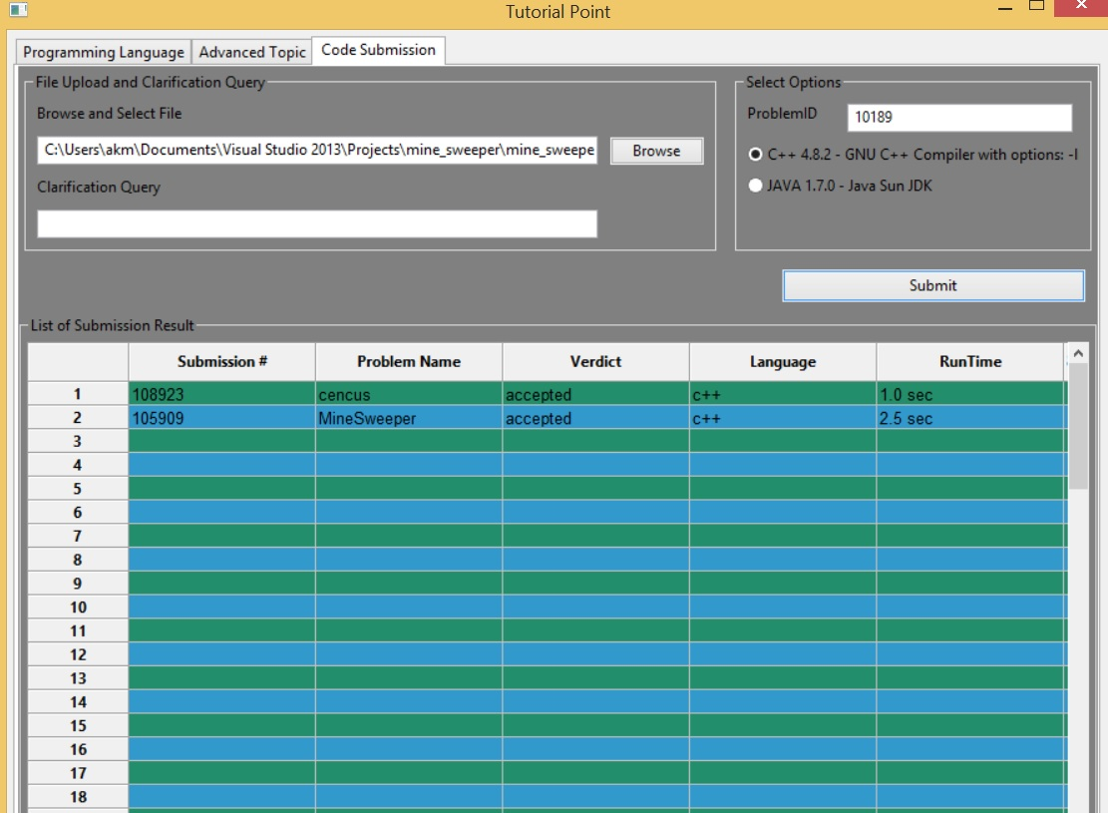
Fig 16:

Browse and select the file by clicking the browse button. Then write down problem ID will be given for each problem from select option section at same time students will also need to select the type of compiler depending on the programming language they are going to use to write solution. Finally press the submit button. Students will be able to see all submission result they made using their account.

The online judge page from ACM UVA is look like the below image. The IOI online Judge system is almost similar to this one,

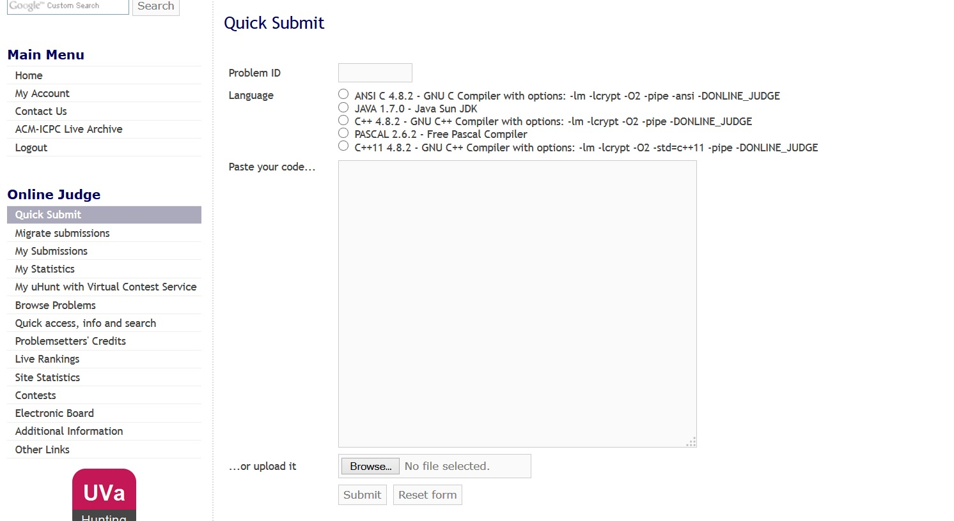

Fig 18:

The verdict for minesweeper problem that I have submitted is,
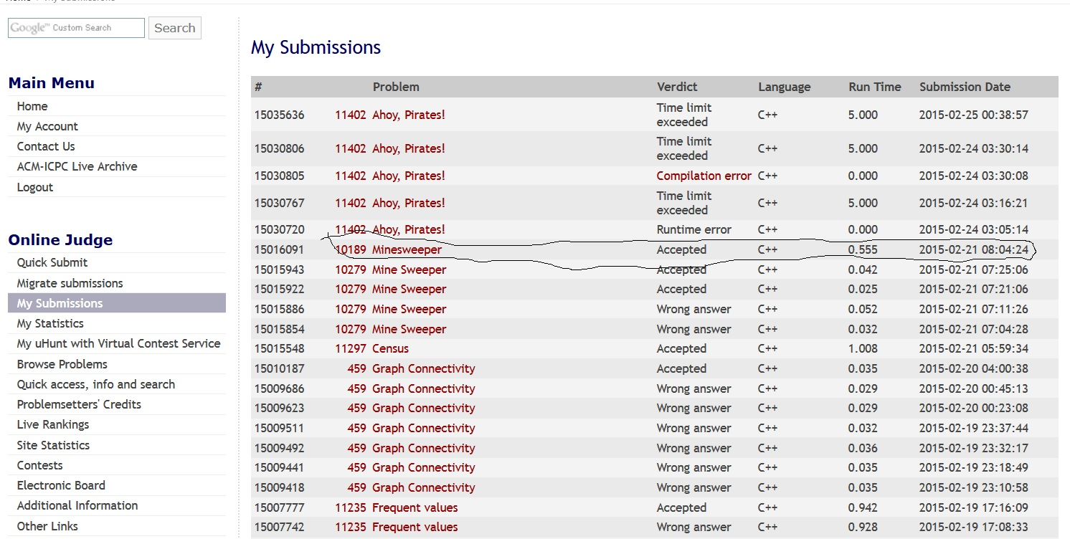
Fig 20:
The accepted verdict is marked with black color.

Learning Outcome:

There will be several learning outcome for students if they use this ‘tutorial point’ application. They are

- Students will learn about structural programming
- They will learn about different aspect of programming languages
- They will be able to write programs and solve critical thinking problems
- They will learn about Integrated Development Environment
- They will learn about visual studio and how to use it to write win32 console program
- They will be able to prepare for participating in International Olympiad in Informatics
- It will help students to develop their critical thinking level and prepare them to solve more challenging problems

Learning Outcomes in terms of Software Engineering:

Things the students are going to learn about software engineering are graphical user interface, code writing style, debugging process, testing process and authentication process. They will learn about properly designing a graphical user interface to simulate a real life problem. Students know that they are going to use this application to simulate the environment they are going to experience in the International Olympiad competition. So all the design of GUI of this application is kind of mimic the IOI environmental setup. So students are going to learn about implementation of simulation environment using software engineering design process.

They will also learn about how to put different options on the GUI template to ease the user interaction with the application. When write solution for different problems using programming language they learn about the proper way to write down code that is coding style. They will learn about debugging process when there is something wrong about the solution or in programming code.

